HOSPITAL MANAGEMENT SYSTEM

1. Introduction
The Hospital Management System (HMS) is a software application developed to manage hospital operations such as patient registration, doctor management, and appointment scheduling. The system helps hospitals maintain records digitally and improves efficiency by automating manual processes.
This project is implemented using Java, with a structured folder system including database files and user interface components. The application provides a centralized platform for managing hospital data and streamlining administrative tasks.
Hospital Management Systems are widely used to:
- Store patient information
- Manage doctor details
- Schedule appointments
- Maintain hospital records
- Improve service efficiency

2. Problem Statement
Traditional hospital systems rely heavily on manual record-keeping, which leads to:
- Data loss
- Time-consuming processes
- Human errors
- Difficulty in managing patient records
- Inefficient appointment scheduling
Therefore, a computerized system is required to:
- Automate hospital operations
- Maintain accurate records
- Improve efficiency
- Provide quick access to patient and doctor information

3. Objectives
The main objectives of the Hospital Management System are:
- To manage patient records efficiently
- To maintain doctor information
- To schedule appointments automatically
- To store hospital data securely
- To reduce paperwork
- To improve hospital management

4. Scope of the Project
The system can be used in:
- Hospitals
- Clinics
- Medical centers
- Healthcare institutions
Future enhancements may include:
- Billing system
- Pharmacy management
- Laboratory management
- Online appointment booking
- Report generation

5. System Overview
The Hospital Management System consists of the following main modules:
- Login System
- Dashboard
- Patient Management
- Doctor Management
- Appointment Scheduling
- Database Management
The application interface includes screens such as:
- Login screen
- Dashboard
- Patient management screen
- Doctor management screen
- Appointment scheduling screen

6. System Architecture
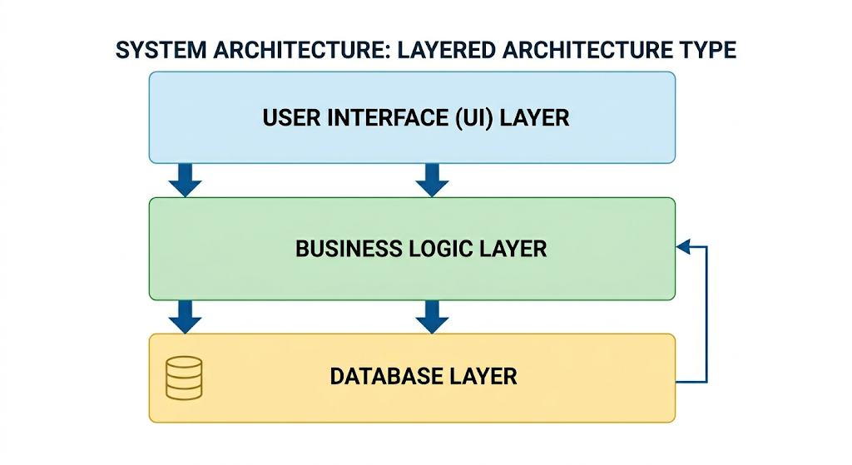

7. Technologies Used
Technology | Purpose
Java | Application development
JDBC | Database connectivity
MySQL / Database | Data storage
Swing / GUI | User interface
IDE (IntelliJ / Eclipse / NetBeans) | Development environment

8. Hardware Requirements
- Processor: Intel i3 or above
- RAM: 4 GB or more
- Hard Disk: 500 GB
- Monitor: 15-inch display

9. Software Requirements
- Operating System: Windows / Linux / Mac
- Java JDK: Version 8 or higher
- Database: MySQL
- IDE: Eclipse / IntelliJ / NetBeans

10. Modules Description

10.1 Login Module
Purpose:
- Authenticate users
- Provide secure system access
Functions:
- Username validation
- Password verification
- Login authentication

10.2 Patient Management Module
Purpose:
- Store patient information
Functions:
- Add patient
- Update patient details
- Delete patient
- View patient records

10.3 Doctor Management Module
Purpose:
- Manage doctor information
Functions:
- Add doctor
- Update doctor details
- Delete doctor
- View doctor records

10.4 Appointment Scheduling Module
Purpose:
- Schedule appointments between patients and doctors
Functions:
- Book appointment
- Update appointment
- Cancel appointment
- View appointment list

10.5 Dashboard Module
Purpose:
- Provide overview of system data
Functions:
- Display system statistics
- Quick navigation
- System summary

11. Database Design

Tables Used
- Patient Table
Field | Type
Patient_ID
Name
Age
Gender
Contact
Address
- Doctor Table
Field | Type
Doctor_ID
Name
Specialization
Contact
- Appointment Table
Field | Type
Appointment_ID
Patient_ID
Doctor_ID
Date
Time

12. UML Diagrams

Use Case Diagram
Actors:
- Admin
- Doctor
- Patient
Use Cases:
- Login
- Manage Patients
- Manage Doctors
- Schedule Appointment
- View Dashboard

Class Diagram
Classes:
- Patient
- Doctor
- Appointment
- User
- Database

13. Advantages
- Easy data management
- Fast record retrieval
- Reduced paperwork
- Improved efficiency
- Secure data storage

15. Future Enhancements
- Online appointment booking
- Billing system
- Pharmacy management
- Laboratory system
- Report generation
- Mobile application

16. Conclusion
The Hospital Management System successfully automates hospital operations such as patient management, doctor management, and appointment scheduling. The system improves efficiency, reduces manual work, and provides secure data storage.
This project demonstrates practical implementation of Java-based software development and database management in a real-world healthcare environment.
17. Source Code
package com.hospital;
import com.hospital.ui.LoginFrame;
import javax.swing.SwingUtilities;
import javax.swing.UIManager;
public class Main {
public static void main(String[] args) {
try {
// Set system look and feel for better UI
UIManager.setLookAndFeel(UIManager.getSystemLookAndFeelClassName());
} catch (Exception e) {
e.printStackTrace();
}
// Launch the application on EDT
SwingUtilities.invokeLater(() -> {
new LoginFrame().setVisible(true);
});
}
}

18. Screenshots
